**Final assignment data wangling and AB testing report**

**Question 1**

We are running an experiment at an item-level, which means all users who visit will see the same page, but the layout of different item pages may differ.

Compare this table to the assignment events we captured for user_level_testing.

Does this table have everything you need to compute metrics like 30-day view-binary?

Query code: refer to Final assignment data wangling and AB testing_Suwandy.sql

Analysis study:

There are no missing data (null)

From this table alone, it does not have sufficient data to compute 30 days metric as there is no data about event time as well as item being order time.

**Question 2**

Reformat the final_assignments_qa to look like the final_assignments table, filling in any missing values with a placeholder of the appropriate data type.

Query code: refer to Final assignment data wangling and AB testing_Suwandy.sql for the Reformat data from final_assignments_qa.sql to final_assignments.sql

**Question 3**

Use the final_assignments table to calculate the order binary for the 30 day window after the test assignment for item_test_2 (You may include the day the test started)

Query code: refer to Final assignment data wangling and AB testing_Suwandy.sql

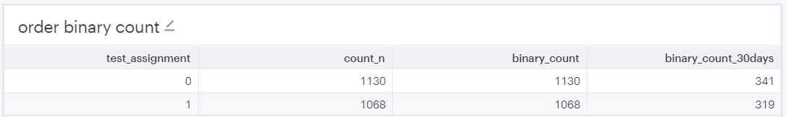

**Question 4**

Use the final_assignments table to calculate the view binary, and average views for the 30 day window after the test assignment for item_test_2. (You may include the day the test started)

Query code: refer to Final assignment data wangling and AB testing_Suwandy.sql

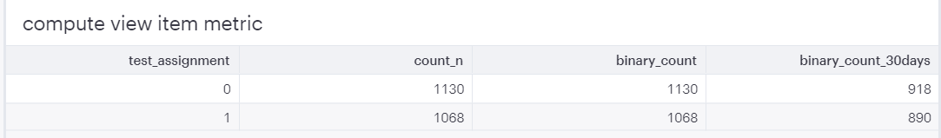

**Question 5**

Use the <https://thumbtack.github.io/abba/demo/abba.html> to compute the lifts in metrics and the p-values for the binary metrics ( 30 day order binary and 30 day view binary) using a interval 95% confidence.

Analysis study:

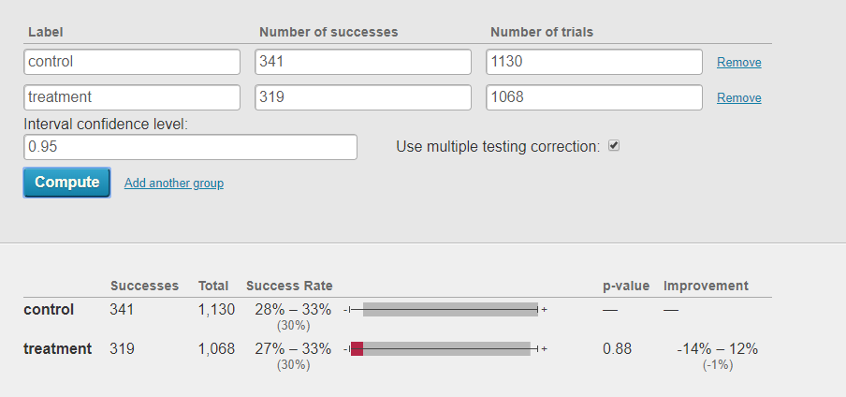

treatment is 1% less order than control group.

Ho = there are no different with between control and treatment

Ha= there are different between control and treatment

treatment is 1% less order than control group.

p value =0.88(88%).At 95 % confidence interval, fail to reject Ho. thus, based on hypothesis testing there are no different between control and treatment.

View_item p value

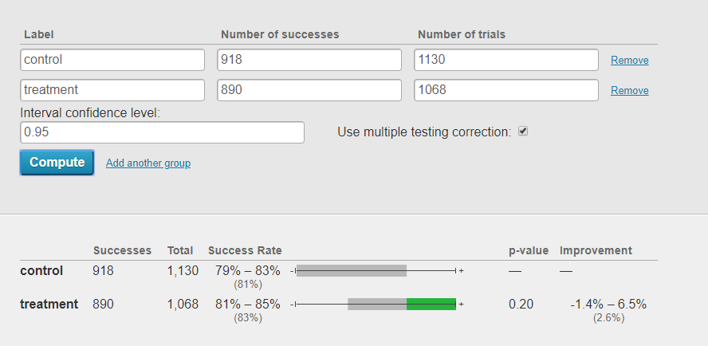

treatment is 2.6% more view than control group.

Ho = there are no different with between control and treatment

Ha= there are different between control and treatment

treatment is 2.6% more view than control group.

p value =0.57(57%).At 95 % confidence interval, fail to reject Ho. thus, based on hypothesis testing there are no different between control and treatment